**Practical No.6**

**Implementation of Cloud Computing Services**

**Aim:** To Implement a concept of Storage as a Service using Google Docs

**Concept:** Storage as a service (STaaS) is a business model in which a company leases or rents its storage infrastructure to another company or individuals to store data. Small companies and individuals often find this to be a convenient methodology for managing backups, and providing cost savings in personnel, hardware and physical space.

A company providing STaaS may be called a storage service provider (SSP). Storage as a service can also be referred to as hosted storage as a Service is a business model in which a large company rents space in their storage infrastructure to a smaller company or individual. In the enterprise, STaaS vendors are targeting secondary storage applications by promoting SaaS as a convenient way to manage backups. The key advantage to STaaS in the enterprise is in cost savings --in personnel, in hardware and in physical storage space.

**Procedure:**

Step 1: Login to Gmail Account and go to Google Docs

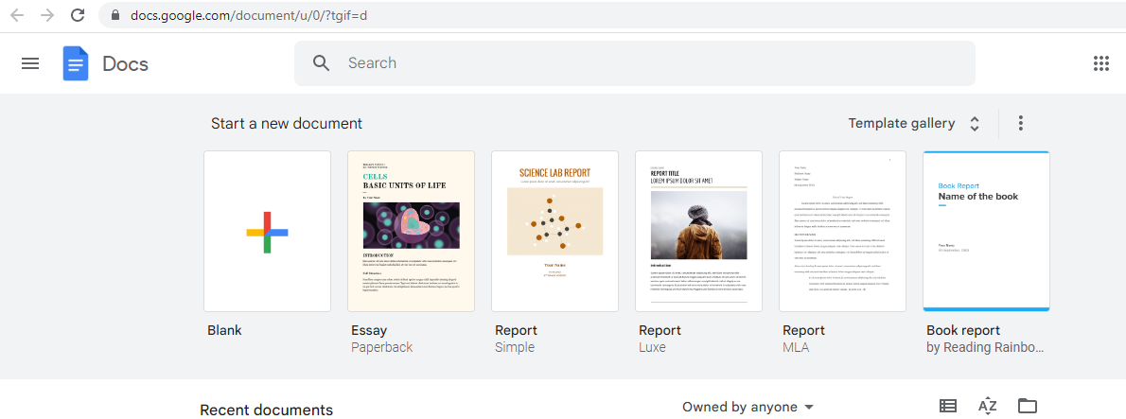

Step 2: Click on three lines which are to the left top corner

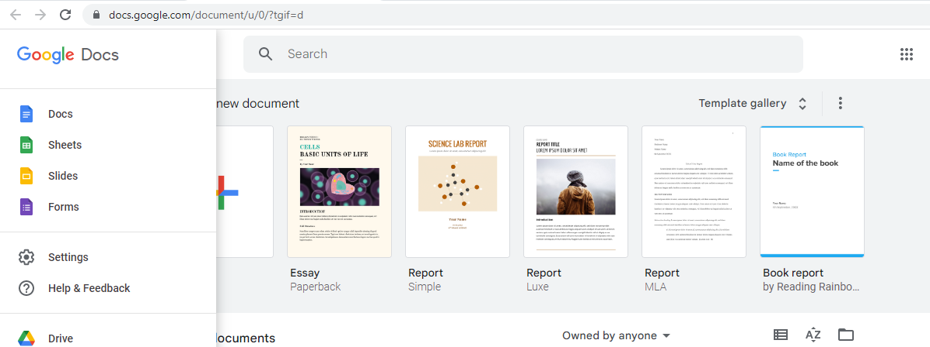

Step 3: Edit one Slide Online with Google Slides

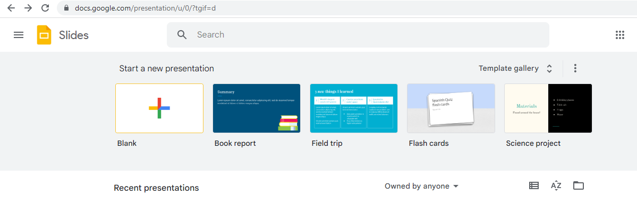

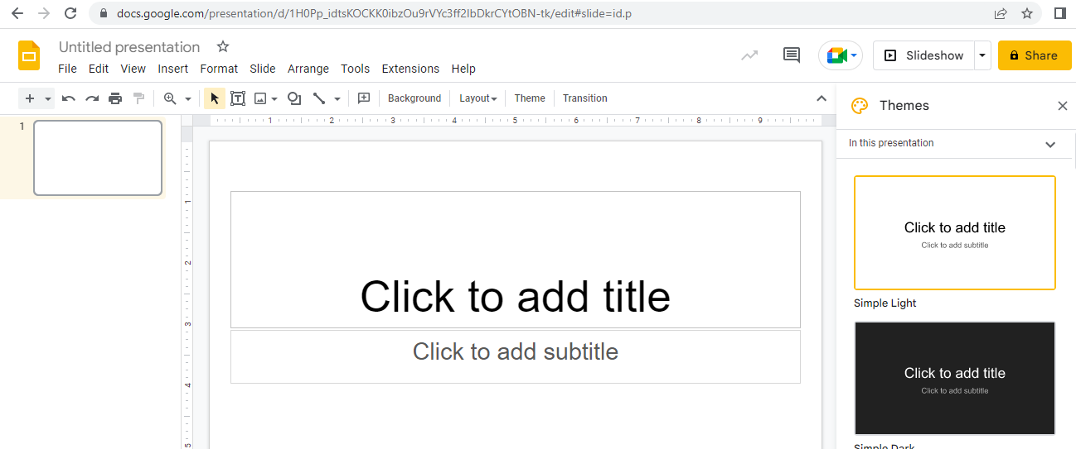

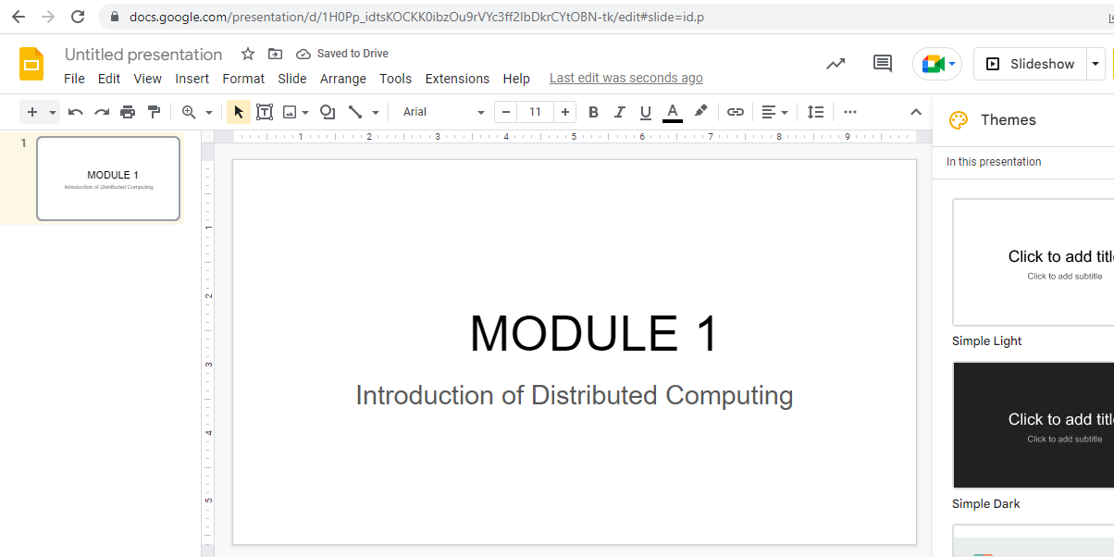

**Conclusion:**

Google Docs provide an efficient way for storage of data. It fits well in Storage as a service (STaaS). It has varied options to create documents, presentations and also spreadsheets. It saves documents automatically after a few seconds and can be shared anywhere on the Internet at the click of a button.

**Practical No.7**

**Implementation of Identity Management using Cloud Computing concept**

**Aim:** To implement concept of Identity Management in cloud computing

**Concept:** Identity management (ID management) is the organizational process for identifying, authenticating and authorizing individuals or groups of people to have access to applications, systems or networks by associating user rights and restrictions with established identities. The managed identities can also refer to software processes that need access to organizational systems.

Identity management includes authenticating users and determining whether they're allowed access to particular systems. ID management works hand-in-hand with identity access management systems. Identity management is focused on authentication, while access management is aimed at authorization.

ID management determines whether a user has access to systems, but also sets the level of access and permissions a user has on a particular system. For instance, a user may be authorized to access a system but be restricted from

The main goal of identity management is to ensure that only authenticated users are granted access to the specific applications, systems or IT environments for which they are authorized. This includes control over user provisioning and the process of onboarding new users such as employees, partners, clients and other stakeholders. Identity management also includes control over the process of authorizing system or network permissions for existing users and the off boarding of users who are no longer authorized to access organization systems.

**Procedure:**

Step1: Open the following link

<https://aws.amazon.com/>

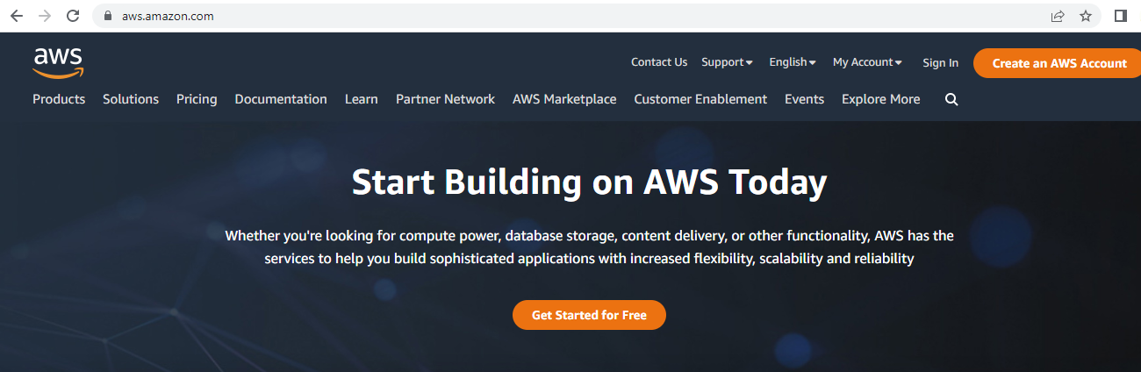

Step2: Go to my Account-> AWS management console

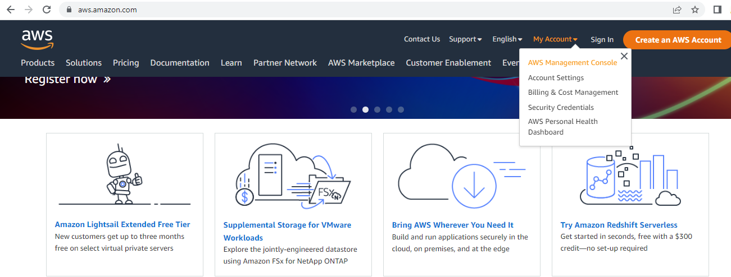

Step3: click on Create new user AWS account

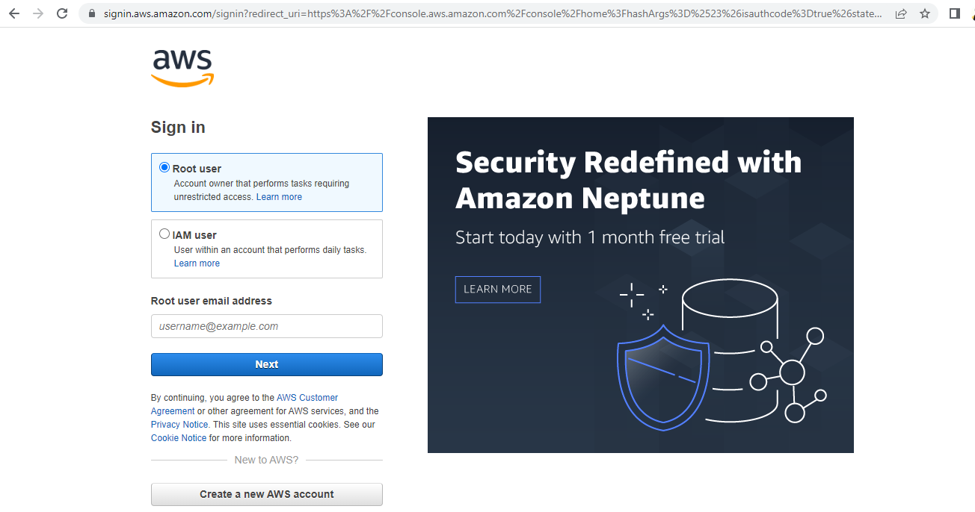

Step4: Fill all the details and click on Verify email address

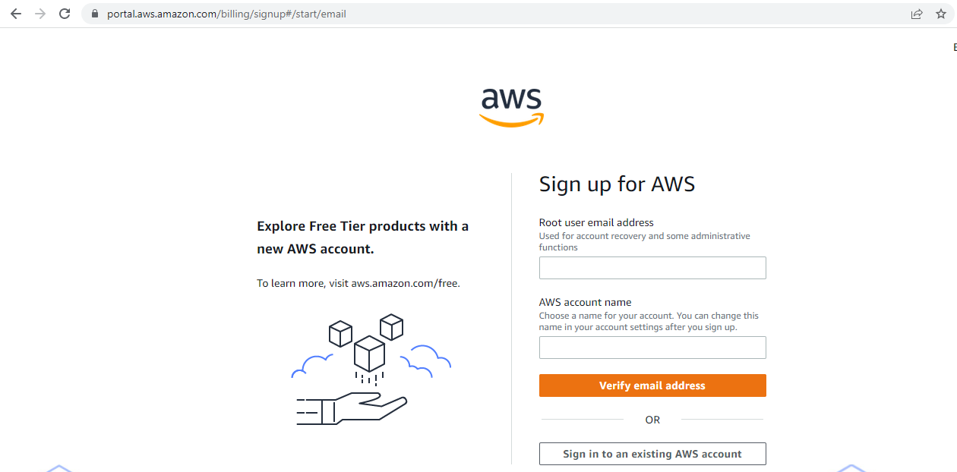

Step 5 : Add verification code and click on verify.

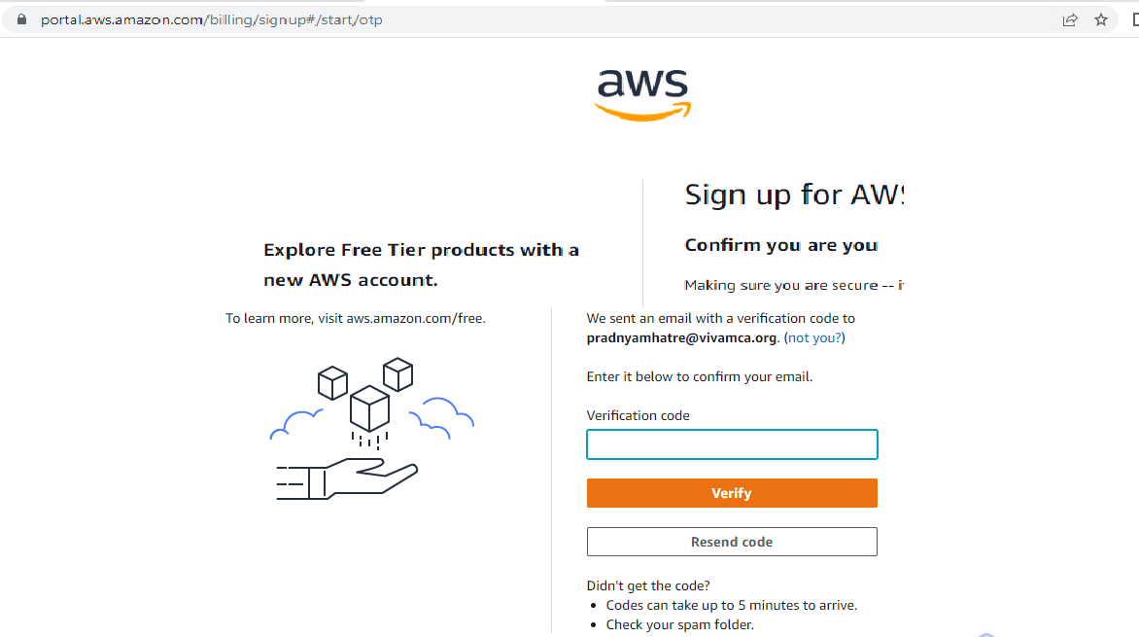

Step 6: Create your password and click on continue.

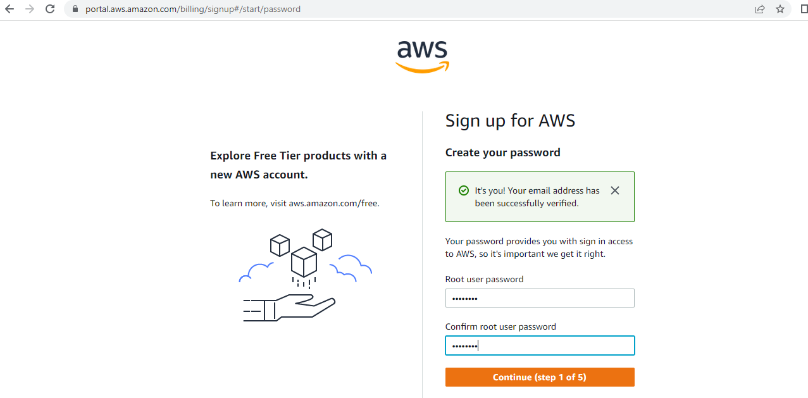

Step 7 : Fill Contact information and click on continue.

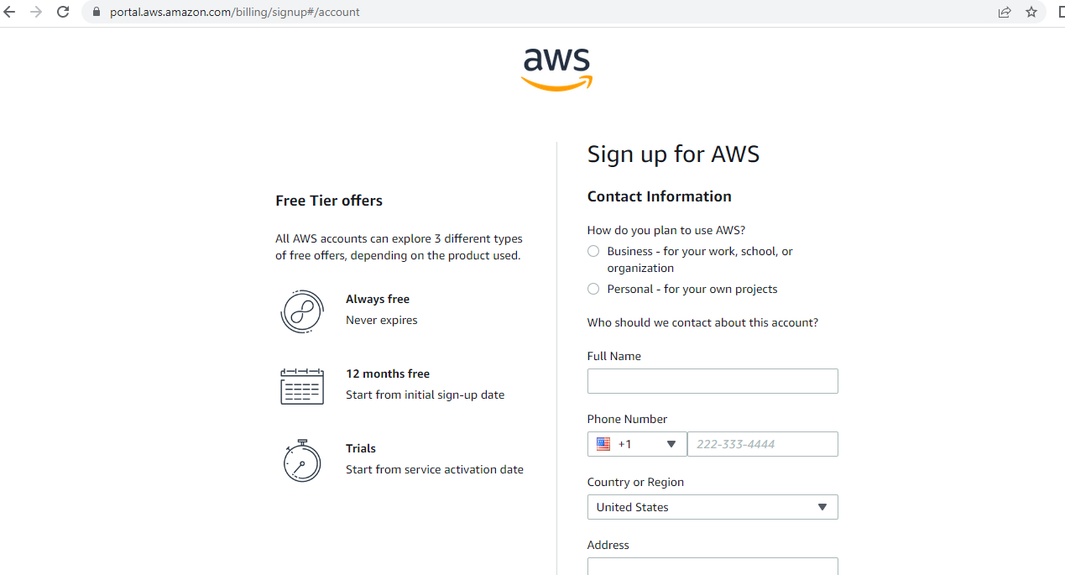

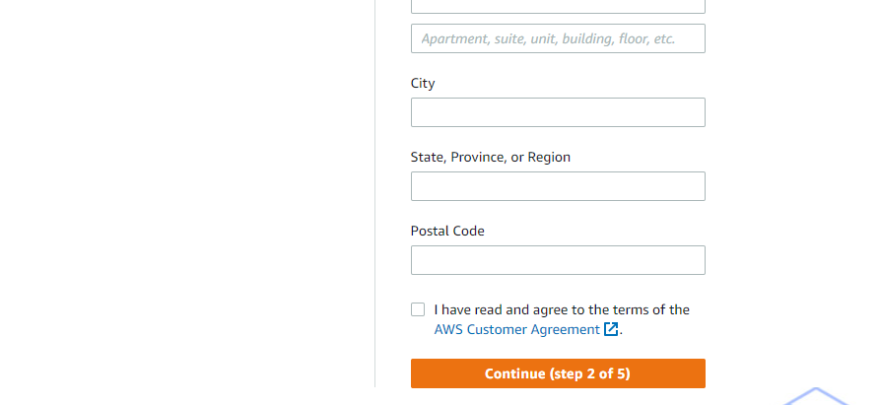

Step 8: Now most curtail step AWS will ask for credit card and debit card details. You have to close the browser

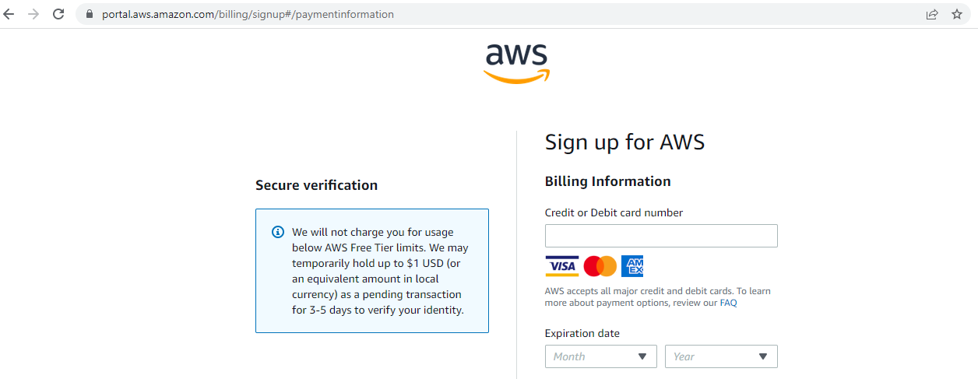

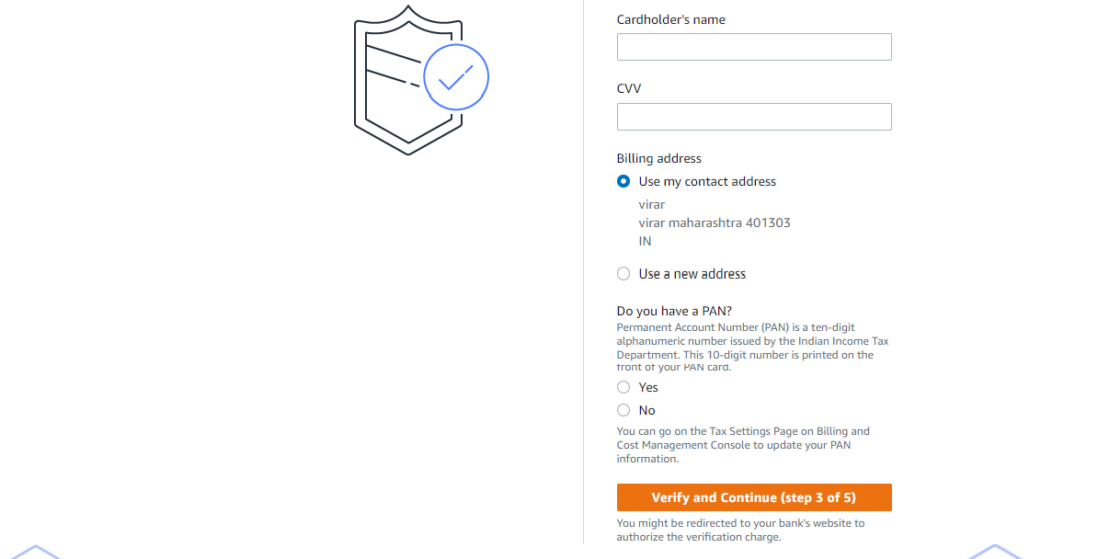

Step8: Go to my Account->AWS Management console

Enter your ID and click on next, After that enter password and click on sign in

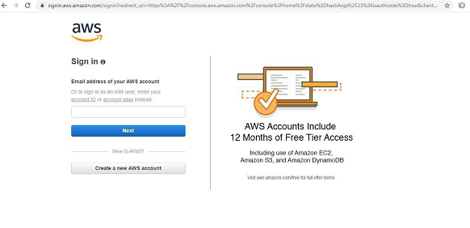

Step 9: you will get the following screen

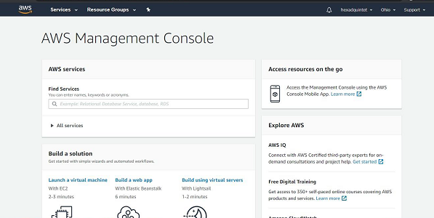

Step 10: Go to My Security credential

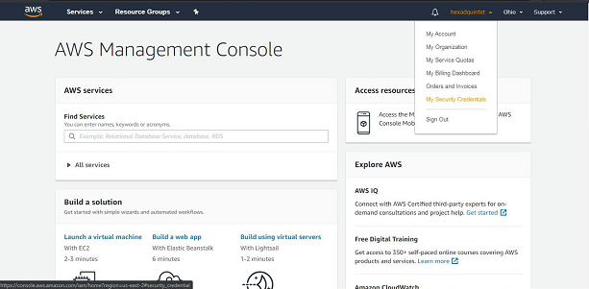

Step 11: now click on user

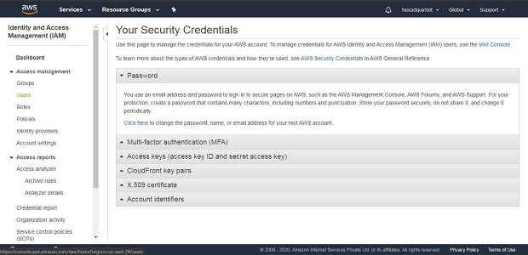

Step 12:Click on add user

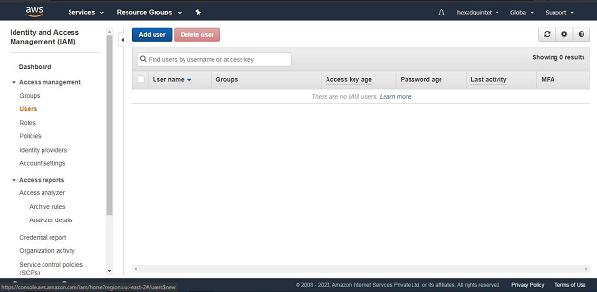

Step 13: Provide the user name and check the check box in front of ***programmatic access*** and ***AWS Management console Access*** and enter the password for new user Click on ***custom password*** and click on next permission

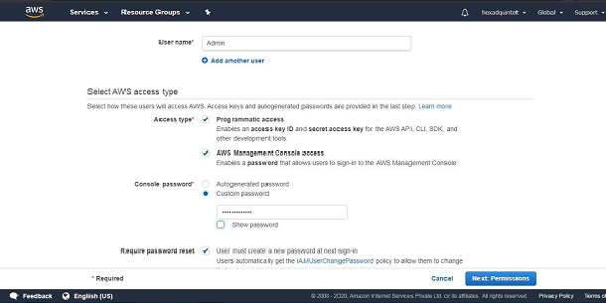

Step 14: click on create Group

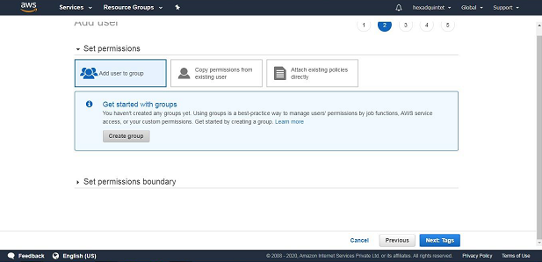

Step15:fill the information and click on Create Group

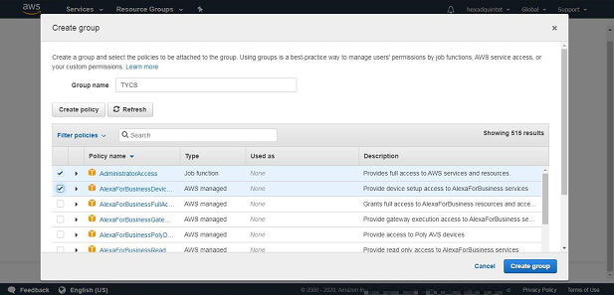

Step16:click on next tag leave blank , again click on next review leave as it is and click on create user

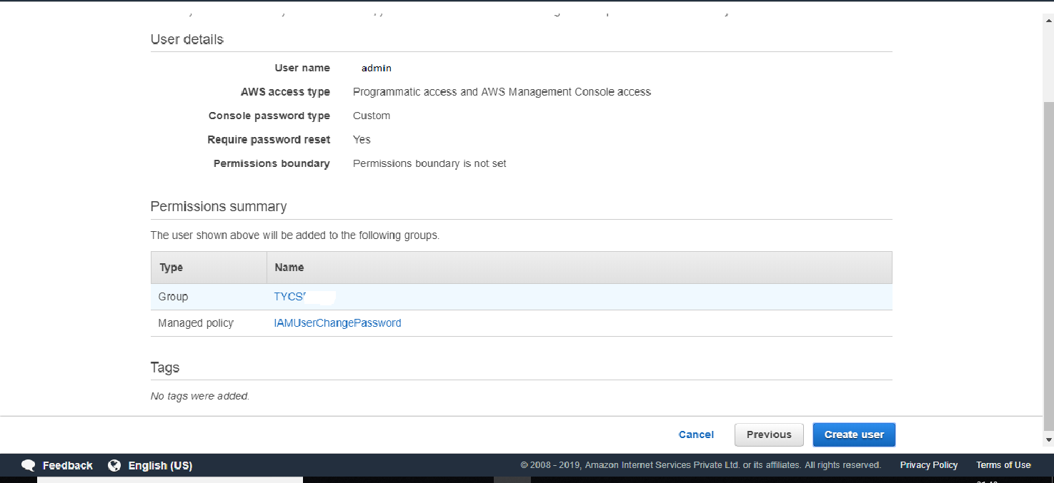

Step 17: click on close

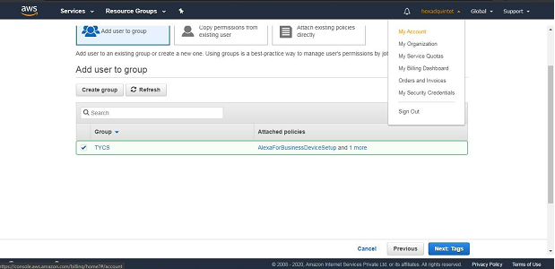

And COPY Account ID

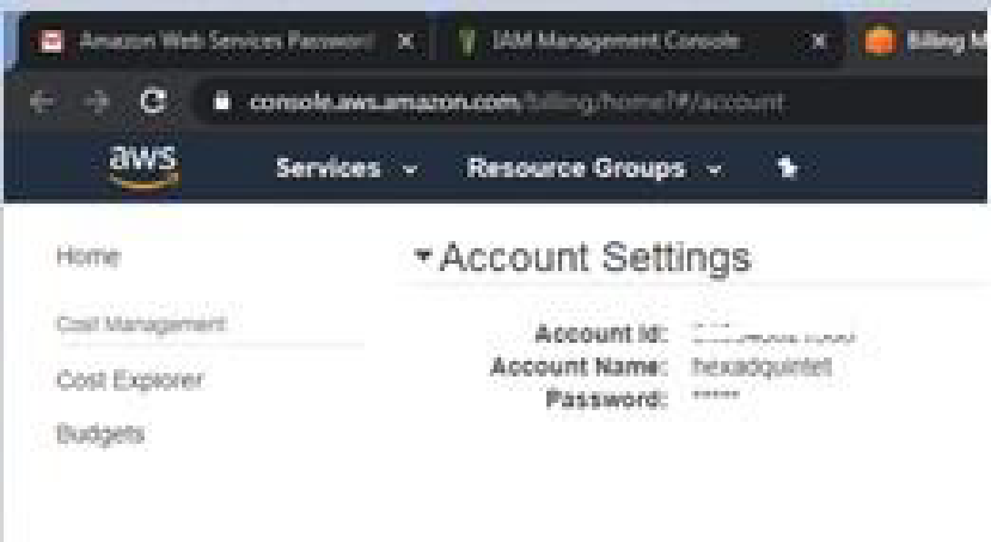

Now logout the admin account and try to login as user(newly created) .

Step 18: again Go to my Account->AWS Management console

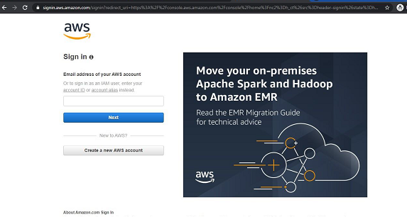

Click on next Provide the Account ID username and password and click on sign in It will ask you to change the password which is been set by administrator

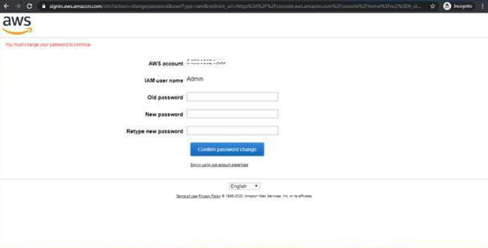 Yow will redirect to home screen

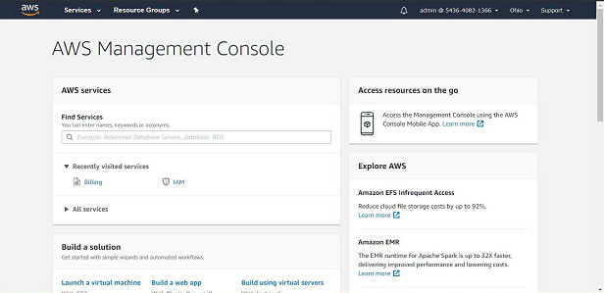

**Conclusion:** Hence we have studied the concept and implementation of identity management using amazon aws.